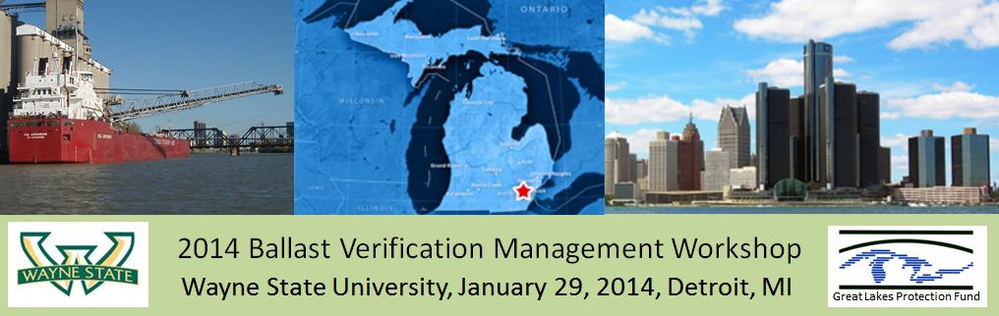

Agenda

Location: Begins at 8:30 a.m. at 5364 Scott Hall (Wayne State University School of Medicine, 540 E. Canfield Street, Detroit, MI 48201). Ends at 5:00 p.m. at the Belle Isle Aquarium (we’ll provide transportation back to the medical school and the Inn on Ferry Street)
WORKSHOP OBJECTIVE
This first Ballast Verification Management Workshop is sponsored by the Great Lakes Protection Fund and designed to facilitate discussion of ballast water verification technology, regulations, and ship operations. The purpose of the workshop is to examine difficult issues in regulation, evaluation, competing and synergistic technologies, user needs including ship design and workforce, interfacing with treatment systems, and commercialization challenges. With participants from the Great Ships Initiative, government officials of both the USA and Canada, technology experts, ship owners and operators, and equipment manufacturers, we intend that the exchange of information will lead to clearer ideas of the way forward to assure safe discharge of ballast water into the Great Lakes and elsewhere as new regulations come into force and new technologies are installed. OPTIONAL: On Tuesday January 28 at 7:30 PM, early arrivals the night before the workshop will have dinner at Pegasus, in Greektown, 558 Monroe St. Detroit MI 48226, (313) 964-6800, . The conference lodging is the Inn at Ferry Street (84 E Ferry Ave, Detroit, MI 48202; see http://www.innonferrystreet.com/). Additional information and a post-workshop report will be found on the workshop website, at http://verifyballast.med.wayne.edu/ballast-meeting.php .

WorkShop AGENDA
[January 29, 2014]
Time | Topic | Speaker or moderator
8:30-9:00 AM | Light Breakfast
9:00-9:10 AM | Welcoming Remarks | Jeffrey Ram
9:10 – 9:15 AM | Preview of the agenda | David Reid
9:15 - 9:30 AM | Introductions by Participants | David Reid
9:30 – 9:45 AM | Keynote: Regulatory Framework | Sarah LeSage
9:50 -10:40 AM | Guided discussion (entire group): Regulatory Framework in Relation to Technology: Interdependence of regulations and technology for invasive species and pathogens* | Moderated by David Reid
Time | Topic | Speaker or moderator
10:40-11:00 AM | Refreshments
11:00 AM –  12:15 PM | Verification and treatment technologies
 | 11 AM – 11:15 AM Informal discussions at technology posters and displays:  Wayne State University, RamLab: AFIDD (Automated Fluorescence Intensity Detection Device) and posters by Roxana Moniri Javid and Ahsan Ahmed.  Turner Designs: Ballast-Check, Pam Mayerfield  Trojan-Marinex: UV-Filtration Ballast Water Treatment Systems, Jim Cosman or Brian Petri  11:15 – 11:30 AM  Lightening Round of Display Summaries, 3 min each:  by the Poster/Display Panel:  Jim Cosman or Brian Petri: Filtration & UV treatment  Pam Meyerfield: Ballast-Check  Roxana Moniri Javid: AFIDD design  Ahsan Ahmed: AFIDD data  11:30 AM – 12 noon  Question and Answers. Poster/Display Panel  12 noon – 12:15 PM: demonstration  Prototype 2.1 live demonstration with algae, RamLab  Prototype 3.0 upgrades (not yet fully operational) | Moderated by David Reid  Moderated by David Reid  Ahsan Ahmed, Roxana Moniri Javid, & Sifat Noman
12:15 -12:35 PM | Travel to Belle Isle Aquarium (On Google Maps, near 600 Inselruhe Avenue, Detroit, MI 48207): We will provide transportation | Instructions by Jeffrey Ram
12:35-1:30 PM | Lunch by LaPalma (Middle Eastern food) at the Belle Isle Aquarium | Richard Kik IV, curator of the Belle Isle Aquarium
1:30-3:30 PM | Ship operations and interactions
 | 1:30 – 1:45 PM Keynote: Problems and Questions about  Applying Verification Systems during Ship Operations  1:45 – 1:55 PM Breakout group instructions  1:55 – 2:40 PM Breakout groups on Ship Operations* | Sifat Noman, or Jeffrey Ram  David Reid
Time | Topic | Speaker or moderator
 | Breakout groups:  Group 1: Rick Harkins, Ahsan Akram, Pam Mayerfield, Tom Stevens, Frank Urban  Group 2: Mark Barker, Sarah Bailey, Amar Basu, Sarah LeSage, Sifat Noman,  Group 3: Chris Wylie, Chris Brown, Allegra Cangelosi, Jim Cosman, Masanori Fujimoto, Roxana Moniri Javid  Circulating: Jeffrey Ram, David Reid, Nancy Christ | Participants as listed in Breakout groups
2:40-2:50 PM | Short break while post-breakout reports are prepared.  Reconvene at 2:50 PM at conference table. | David Reid, Jeffrey Ram, and breakout group notetakers
2:50 -3:30 PM | Discussion of breakout results. Start with report out of each of the three breakouts. | Moderated by David Reid
3:30-3:50 PM | Refreshment break, in front of invasive species exhibits
3:50 – 4:40 PM | Guided discussions  Continuation of ship operations topics,* and  The Future: emerging regulatory, technological, and ship operation action items, issues, and changes | Moderated by David Reid
4:40-4:55 PM | Summary and Future Directions | Sarah Bailey
4:55 – 5:00 PM | Final comments and logistics of wrapping up | Jeffrey Ram
Thank you for participating and assisting in this endeavor!

*Question to be discussed in the morning guided discussion on Regulatory Framework in relation to Technology and in the Breakout sessions on Ship Operations will be chosen from among a list of questions on the following page.

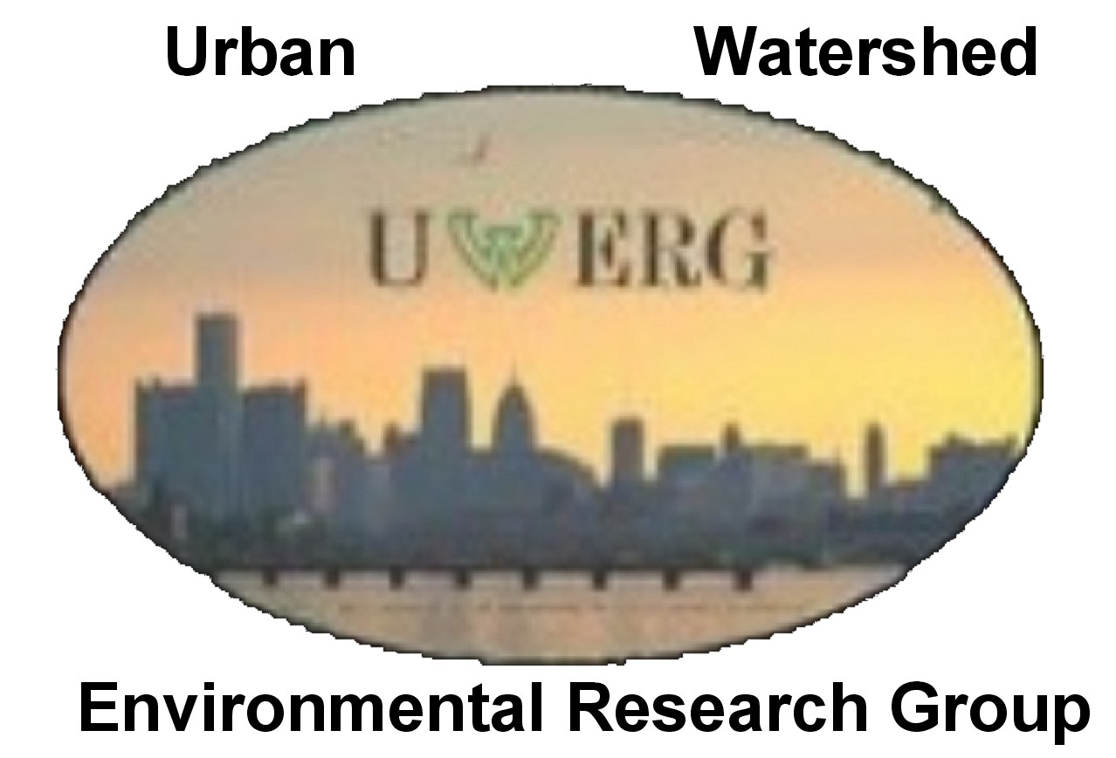
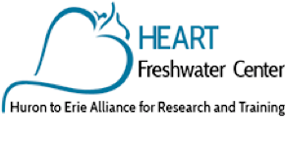
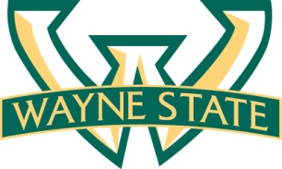

Workshop Discussion Topics
The questions listed below are ones that have been raised at various times by members of the Ram Laboratory. Not all will be discussed during the formal sessions of the meeting. Several will be highlighted by the moderator, David Reid, who will moderate and guide several of the discussions. Others may be brought up in sidebar discussions.
We welcome your suggestions of additional questions.
Note: For the purposes of this document, “verification” means the application of various biological test procedures that would be applied to ship ballast water (could be intake, in tank, or discharge water) after a type-approved treatment system has been installed, to assure continued successful operation and effectiveness of the installed system.
Regulatory Framework in relation to verification technologies (mostly topics for the morning discussion):
1. How might the different regulatory frameworks among states (Michigan and California, for example), USCG, IMO, and Canada affect the need or application of verification technologies? Are there preferred or required verification procedures? If so, which ones? What verification procedures are used in other countries?
2. What kinds of verification data are needed by regulators? How frequently? With respect to specific toxic strains in V. cholera described in IMO and USCG rules for type-approval testing, do tests for these specific strains V. cholera need to be done for verification?
3. Is a live-dead measurement system that is biomass dependent but does not use specific organism counts going to be useful in regulations? How critical are assays of multiple size ranges (as described in IMO and USCG regulations) of organisms to determine treatment efficacy?
4. What are the arguments for and against automated verification technology? Should an automated device be operated with remote control and data monitoring? Are there potential unintended consequences? Will this only apply to US ships or to any ship entering our waters?
5. If treatment verification systems become mandatory, what is the timeline for this requirement? eir implementation? Which agency(s) will have enforcement authority? How might new verification technologies enable regulations and their enforcement?
6. Is it likely that current ETV protocols will be upgraded or amended ? Should, and how can regulations be modified to incorporate new technologies? If so, which areas are likely to change? Which areas are the most controversial and why?
7. What biological considerations are there? For example, are there subgroups of live organisms or live but inactive states (e.g., diapausing organisms) that are undetected by the verification systems and are they a major objection to full implementation of rules?
Ship operations and interactions
Verification operation and maintenance:
1. What kinds of verification data are needed by ship operators?
2. Who services and runs the verification equipment on board the ship? Who calibrates it (OR, is automated calibration a requirement?) Who refills perishables and consumables needed by the verification equipment? Will the ship carry and install replacement parts, in case the device breaks? . If the verification device fails or is not properly maintained, how might that affect ballast water operations? Can the ship still discharge its water?
3. What do we do with waste products (e.g., fluorescein, filters, buffers, expired perishables, etc.)? Can the waste be dumped overboard? Can the device waste go into the general waste tank on the ship or does it need a dedicated waste container?

Verification system installation
4. Where would be the likely location for a permanently installed automated verification device on a ship? Next to the ballast tank, engine room, etc.? As part of a treatment system? Or independent of the treatment system? What dimensions or space constraints exist for such equipment?
5. How many verification systems are needed on a ship? One for each ballast tank? Or just a single one on the intake and/or discharge lines?
6. What physical conditions will an automated verification device have to endure? What thermal and vibrational stress will it be subjected to? What structures have to be dealt with to install a verification system?

Other questions relating to ship operations
7. Do most ships in the Great Lakes have an internet connection? If so how do they connect to the net? Which network do they use? GSM network? What about as salties when more than 200 km from land? (These are considerations for remote control and monitoring
8. Should a version of the verification equipment be portable (therefore carried on and off ship for ad hoc or planned testing) or should it be permanently installed in association with the treatment system? If portable, what are the size and weight limitations?
9. Should verification equipment have the capability of being operated remotely? (e.g., activated, at will, by enforcement officers from a remote location, possibly without authorization by the captain?) At what points in the treatment cycle should verification tests be run?
10. How many times will the ballast tanks of a ship be treated and the treatment need to be verified over the course of the ship’s journey? If a ship travels from one Great Lake to another, does the ballast water need to be treated and verified before discharge? How much time would such a ship take to go from one port to another? (relevance: how much time is available and at what point should the ballast treatment be verified?)
11. What type of water do you need to use when verifying viability? Freshwater (like the lakes)? Or purified ambient ballast water?

The Future
1. What are the top 3 challenges going forward in eliminating the discharge of non-native organisms in ballast?
Other future questions:
2. Which organisms are projected to become a threat? Do they give positive responses in ETV, FDA, or chlorophyll-based tests? What is their size range?
3. Will future regulations have a broader test for microorganism viability (i.e., more than just E. coli, Enterococcus spp., and toxicogenic V. cholera)?
4. What is being done to encourage ship owners/ companies to implement verification systems? What dates in the near future (2016, and beyond) are most relevant?

