The closest parking to Scott Hall (540 E. Canfield St, Detroit, MI 48201) is the underground parking for Detroit Receiving Hospital (see map), off of St. Antoine St. Here’s a map and driving directions to get to it:
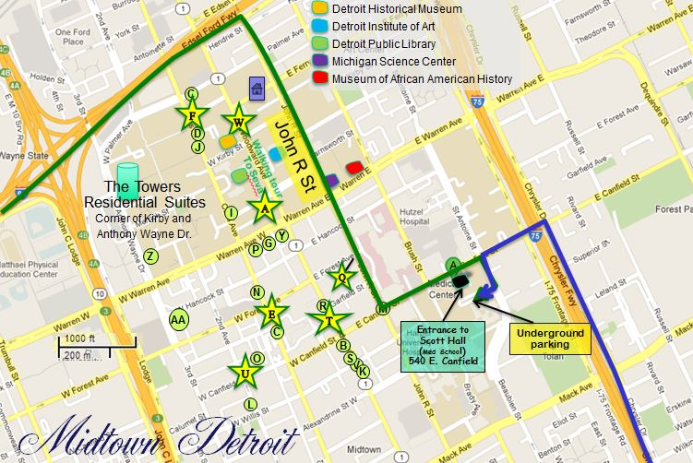

Directions to Detroit Receiving Hospital parking from west of Detroit (green line on map)
Take the I-94 Freeway east to the Woodward Avenue/John R exit (exit 215C).
Turn right onto John R St (one way to the right is the only direction you can go).
Drive south on John R St to E. Canfield St.
Turn left or east onto E. Canfield St.
Then turn right or south onto St. Antoine Boulevard.
The driveway leading to Detroit Receiving Hospital parking will be on your right just south of the corner building on St. Antoine.

Directions to Detroit Receiving Hospital parking from south of Detroit (blue line on map)
Take I-75 north to the Mack Avenue exit.
Continue north on the service drive until you get to E. Canfield St.
Then turn left or west onto E. Canfield St.
At St. Antoine Boulevard, turn left.
The driveway leading to the Detroit Receiving Hospital parking will be on your right after you pass the corner building on St. Antoine St.

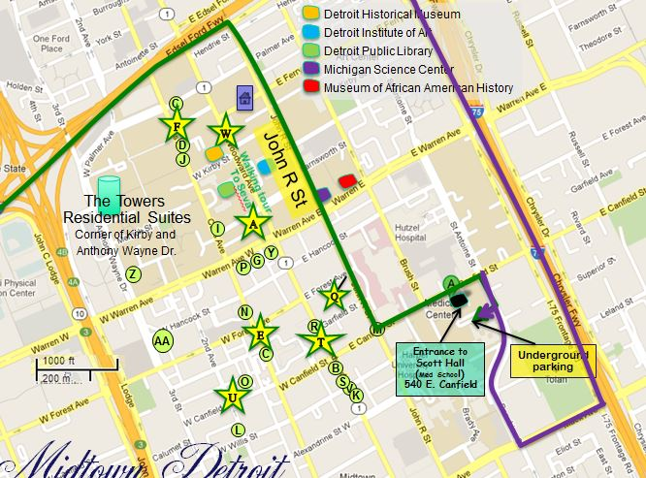

Directions to Detroit Receiving Hospital parking from east of Detroit (purple line on map)
Take I-94 west to southbound I-75.
Stay in the right lane.
Once you are on I-75 south, take the Mack Avenue exit.
Turn right or west onto Mack Avenue.
Then turn right or north onto St. Antoine Boulevard.
Detroit Receiving Hospital parking will be on your left after you pass Children's Hospital of Michigan.

Directions to Detroit Receiving Hospital parking from north of Detroit ( not shown but you can figure it out)
Take I-75 south to the Warren Avenue exit.
Turn right or west onto Warren.
Then turn left or south onto St. Antoine Boulevard.
Detroit Receiving Hospital parking will be on your right after you cross East Canfield Road.

Driving directions Inn on Ferry Street to Scott Hall (however, we suggest that you take the Inn’s shuttle to Scott Hall and leave your car at the Inn; we will return you to the Inn at the end of the day). If you drive to Scott Hall, park in the surface lot using the parking card that we will leave for you at the Inn (or return the parking card to us if you leave your car at the Inn).

